**Lambda Function**

This is home page search for lambda function and choose lambda function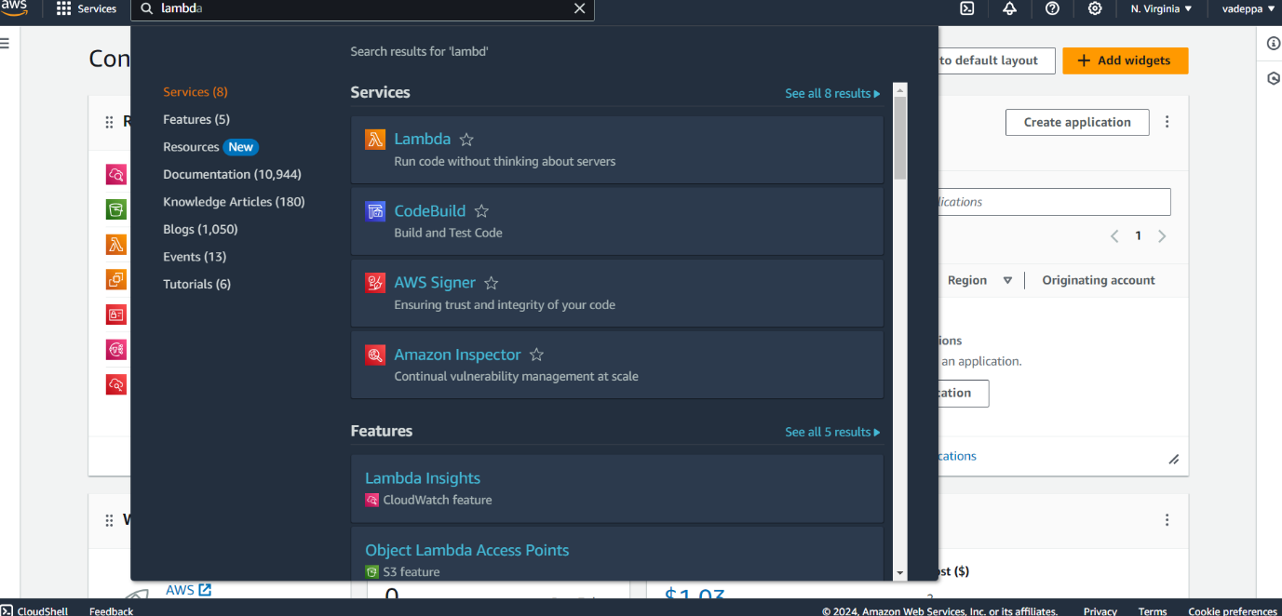

Create function here

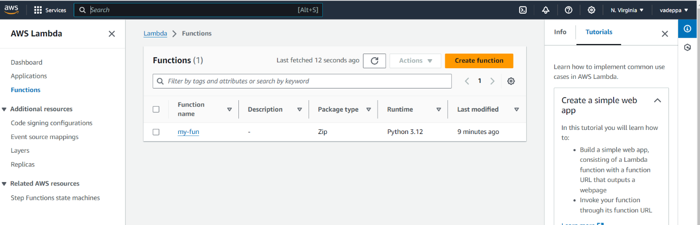

Give function name and choose Runtime name like python, java, node.js

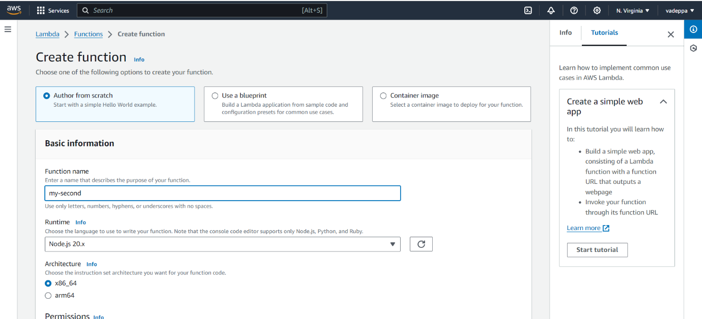

And choose create function than create

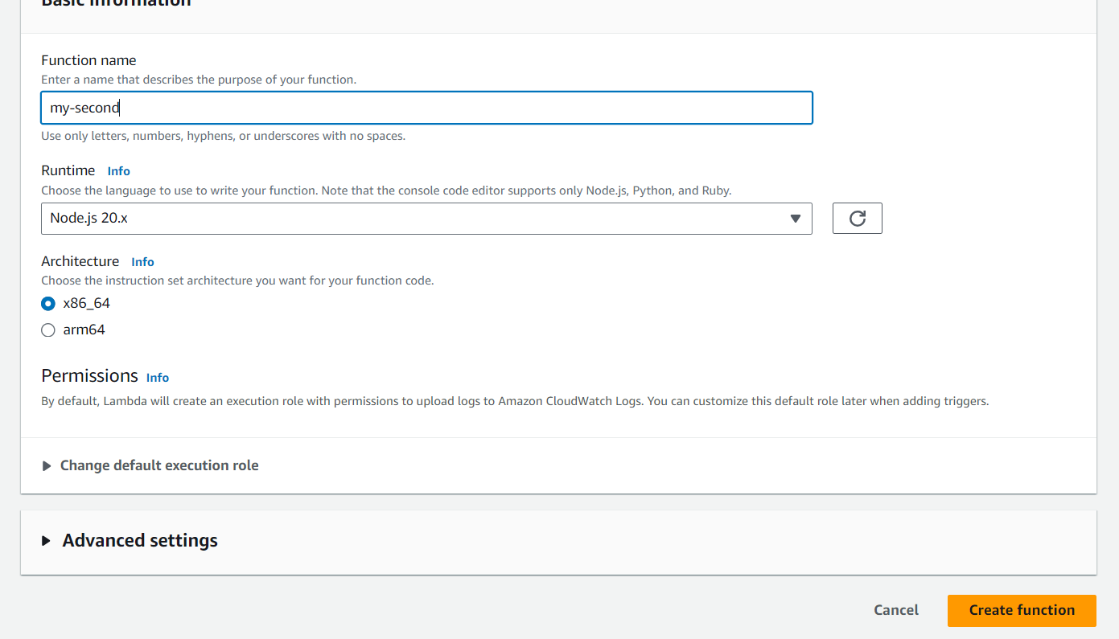

Successfully create function my-second and Add trigger

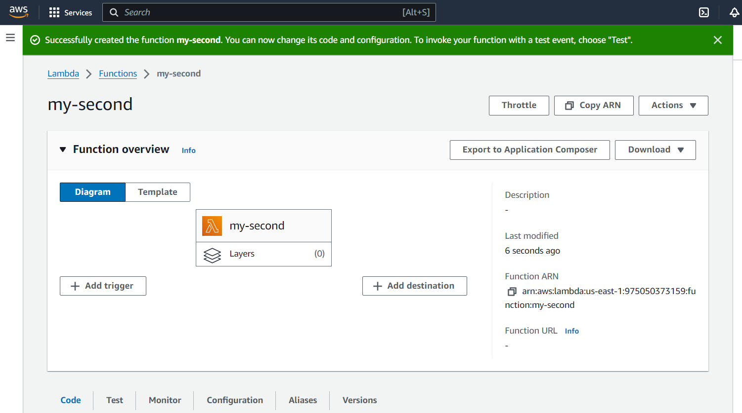

Here I took trigger as S3 bucket

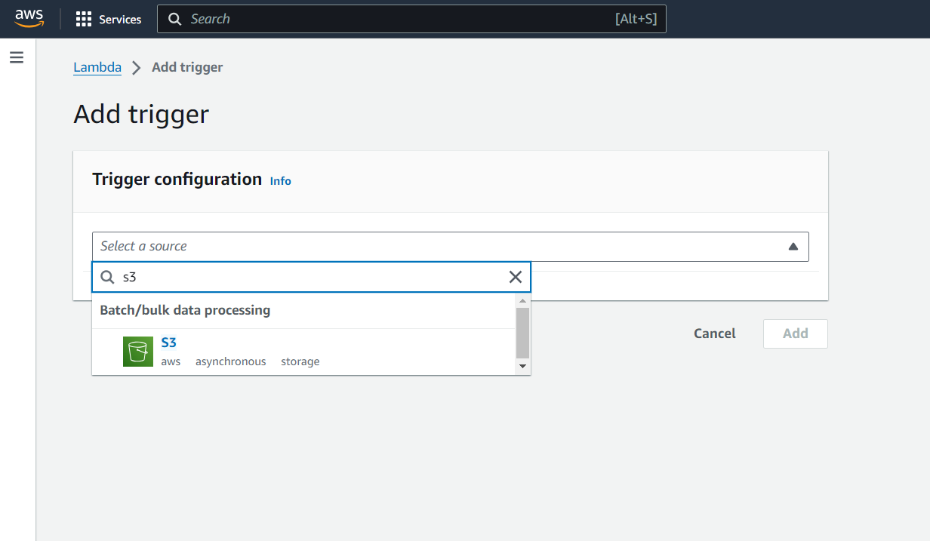

Before that create one bucket and it will be empty created successfully bucket

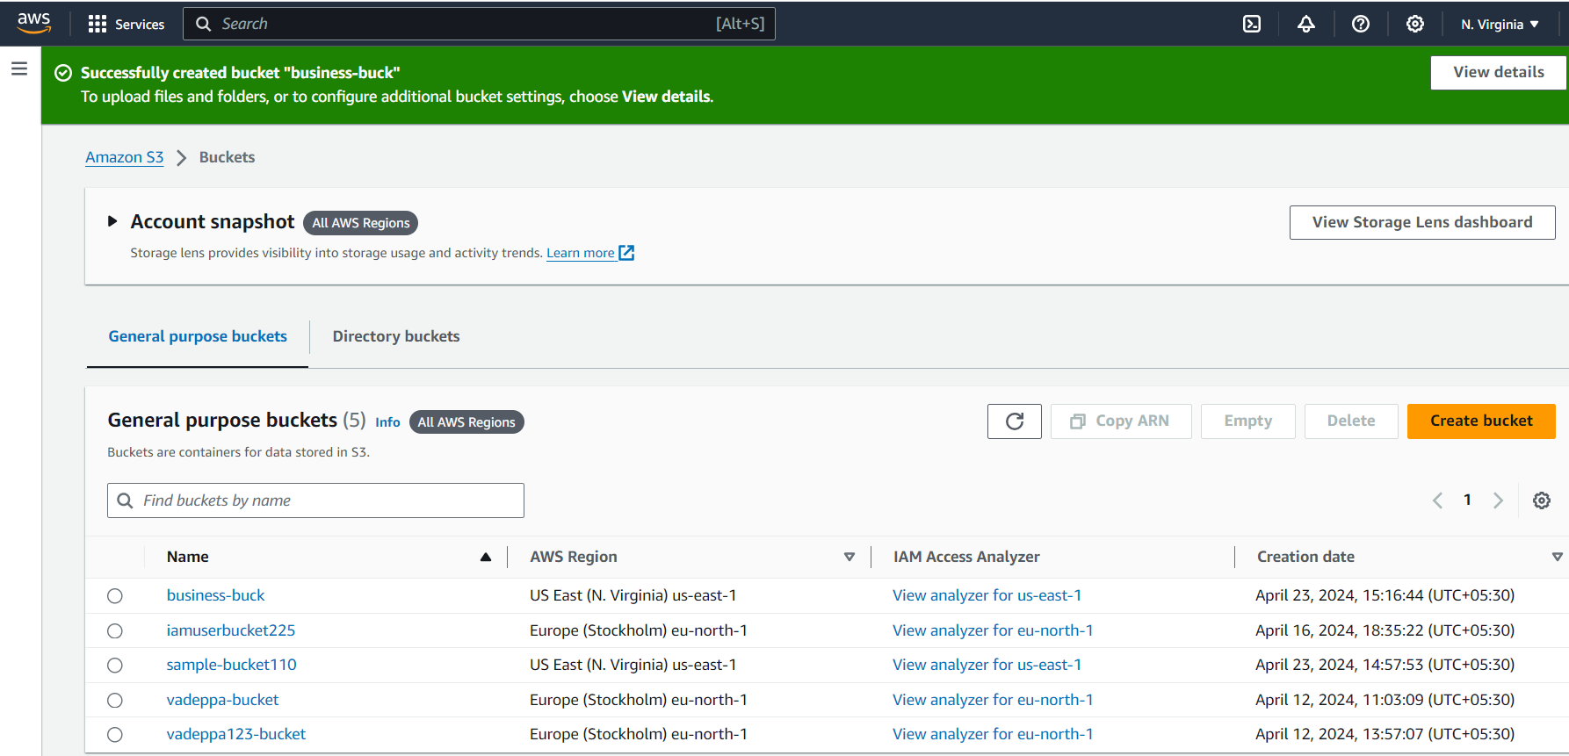

Add the lambda function to S3 bucket

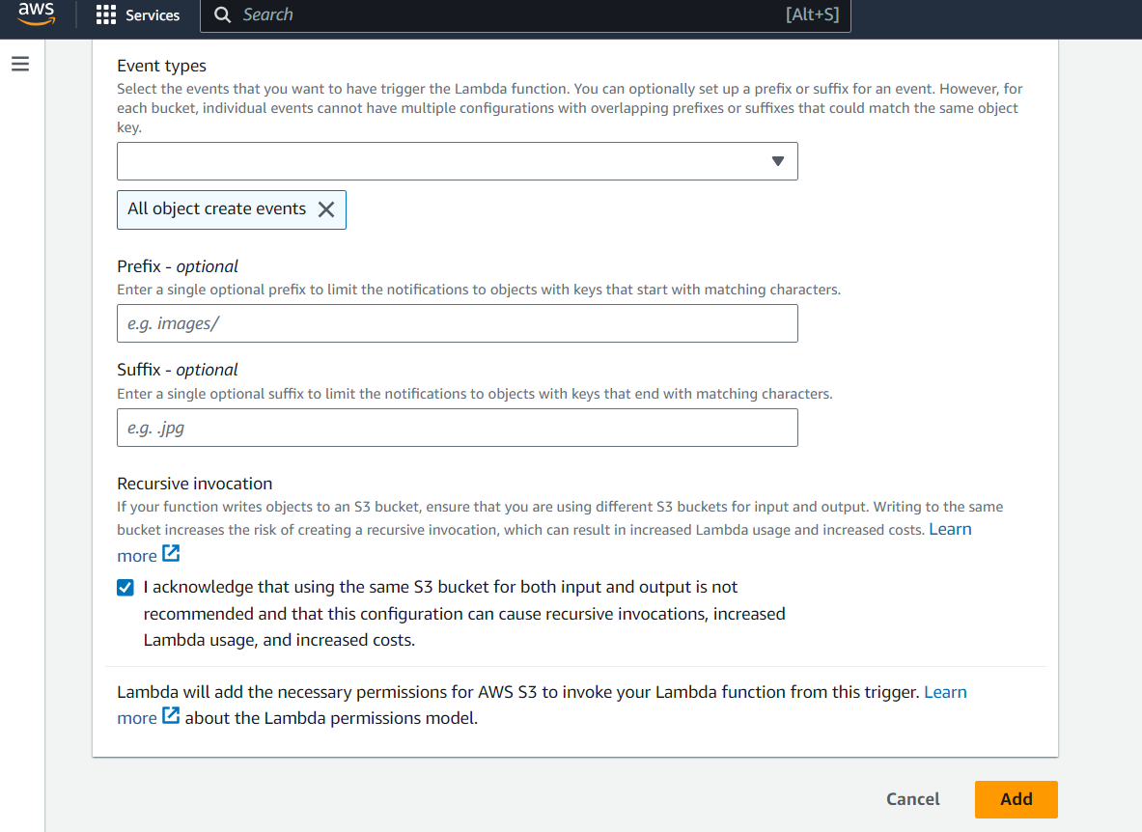

Here writes code in choose code options and write python code

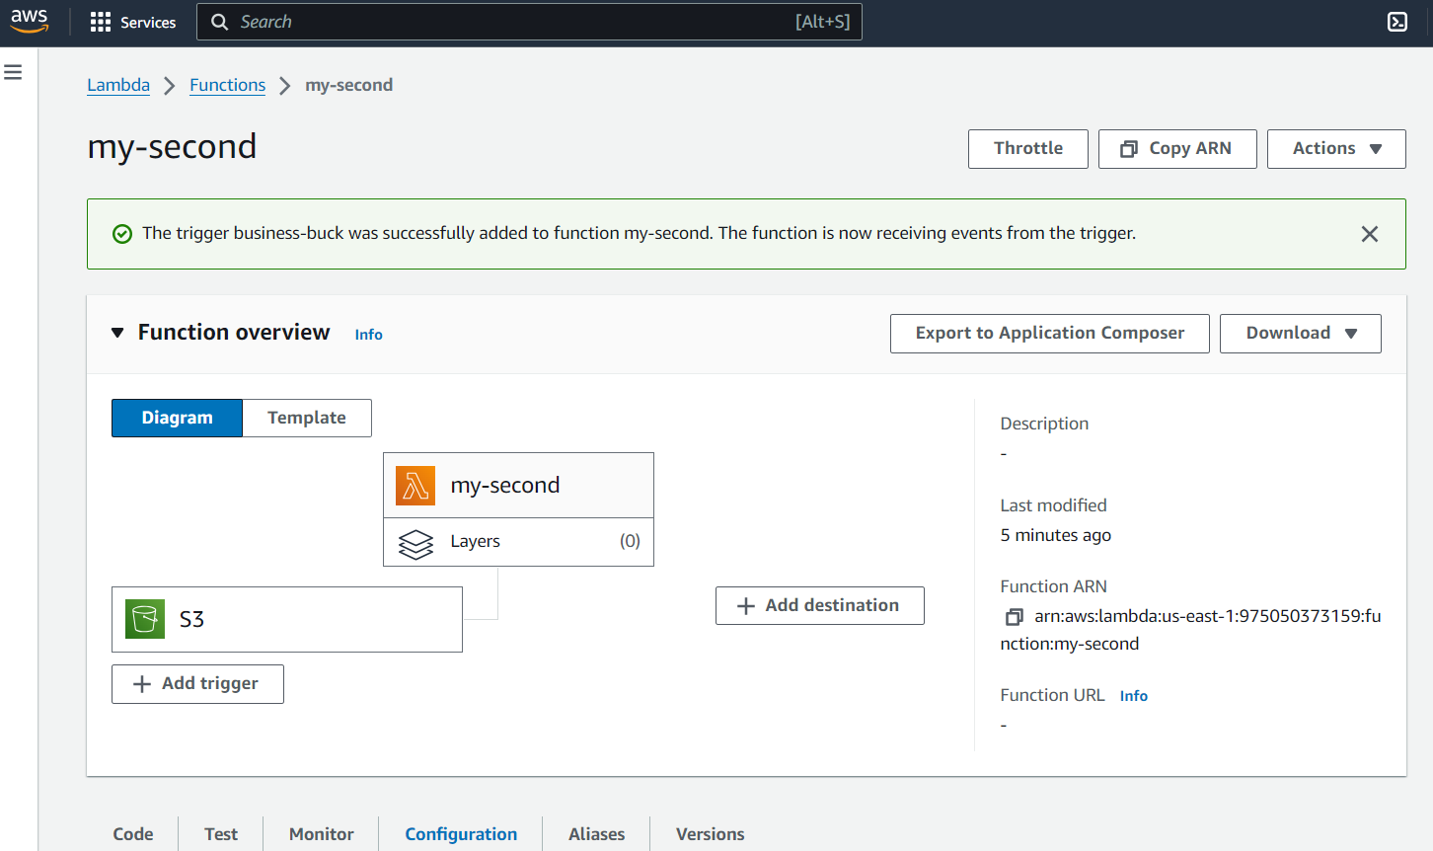

Give event name and save it

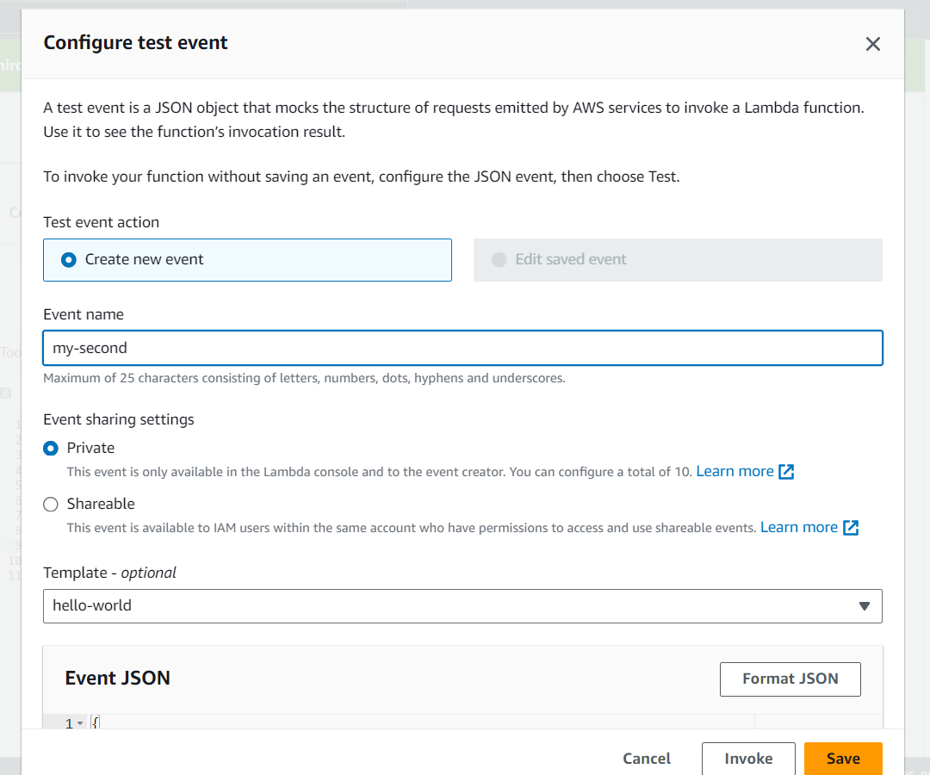

Write code and click Deploy option it is for code saving and Run the code by using Test option

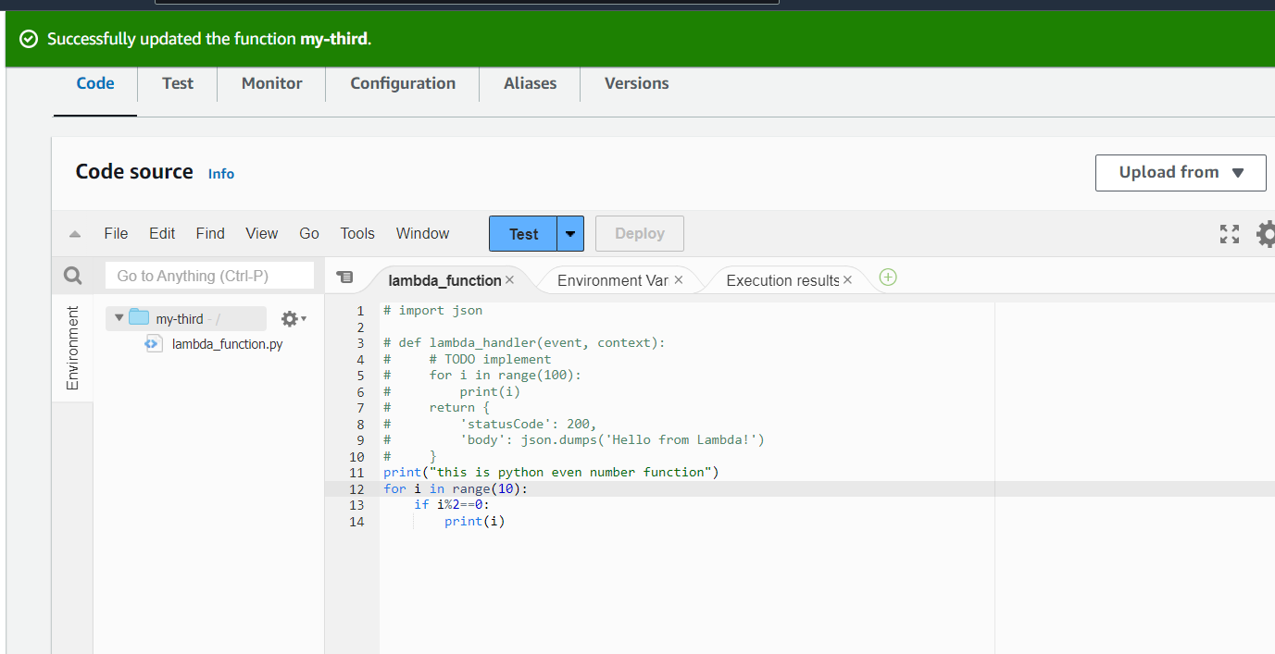

Then click Monitoring and choose view CloudWatch we can see triggers

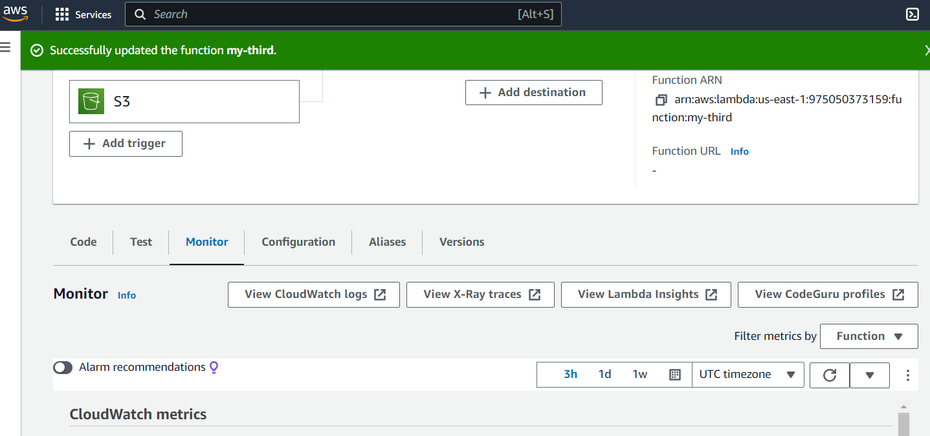

Here two-time S3 bucket is triggered

